pstat-126-extra

Zejie Gao

2023-03-23

Our goal is to model the response mpg in terms of the rest of the variables (except name).

Partition the data set into two sets a training data and a test data. Remove every fifth observation from the data for use as a test sample. Perform an exploratory analysis. Comment on your findings. Perform a regression analysis and come up with the best multiple linear regression model that explains the response mpg in terms of the rest (except name). Comment on your findings and explain the methods and strategies that you employed in order to select the model you picked. Things you have to include in this part: - Model diagnostics - Justification on whether it is necessary or not to do any transformation on the response or the predictors - Variable selection Assess the prediction performance by using the test sample.

Car <- read.table("cars (1).txt",header=T)  
str(Car)

## 'data.frame': 32 obs. of 12 variables:  
## $ name: chr "Mazda RX4" "Mazda RX4 Wag" "Datsun 710" "Hornet 4 Drive" ...  
## $ mpg : num 21 21 22.8 21.4 18.7 18.1 14.3 24.4 22.8 19.2 ...  
## $ cyl : int 6 6 4 6 8 6 8 4 4 6 ...  
## $ disp: num 160 160 108 258 360 ...  
## $ hp : int 110 110 93 110 175 105 245 62 95 123 ...  
## $ drat: num 3.9 3.9 3.85 3.08 3.15 2.76 3.21 3.69 3.92 3.92 ...  
## $ wt : num 2.62 2.88 2.32 3.21 3.44 ...  
## $ qsec: num 16.5 17 18.6 19.4 17 ...  
## $ vs : int 0 0 1 1 0 1 0 1 1 1 ...  
## $ am : int 1 1 1 0 0 0 0 0 0 0 ...  
## $ gear: int 4 4 4 3 3 3 3 4 4 4 ...  
## $ carb: int 4 4 1 1 2 1 4 2 2 4 ...

Car <- as.data.frame(Car)

test_indices <- seq(5, nrow(Car), by=5)  
test_data <- Car[test_indices,]   
train_data <- Car[-test_indices, ]

1. To perform some exploratory analysis on data car, I create a scatterplot matrix to visualize the relationships between all the variables, a correlation matrix to examine the pairwise correlations between variables, and histograms, density plots, and boxplots to explore the distribution of the response variable “mpg”. From the correlation matrix, there are 13.36577% correlation between variables higher than 0.9 or lower than -0.9. This data indicate possible high pairwise collinearity that may impact our data analysis. Based on the histogram and density plot, most of the mpg value fall bettween 15 and 25 and the distribution is right-skewed.

summary(train_data)

## name mpg cyl disp   
## Length:26 Min. :10.40 Min. :4.000 Min. : 75.7   
## Class :character 1st Qu.:15.28 1st Qu.:4.000 1st Qu.:120.5   
## Mode :character Median :19.55 Median :6.000 Median :196.3   
## Mean :20.07 Mean :6.077 Mean :221.8   
## 3rd Qu.:22.80 3rd Qu.:8.000 3rd Qu.:303.2   
## Max. :32.40 Max. :8.000 Max. :460.0   
## hp drat wt qsec   
## Min. : 52.0 Min. :2.760 Min. :1.513 Min. :14.50   
## 1st Qu.: 95.5 1st Qu.:3.098 1st Qu.:2.504 1st Qu.:16.88   
## Median :111.5 Median :3.715 Median :3.203 Median :17.71   
## Mean :145.2 Mean :3.622 Mean :3.168 Mean :17.90   
## 3rd Qu.:180.0 3rd Qu.:3.920 3rd Qu.:3.570 3rd Qu.:18.90   
## Max. :335.0 Max. :4.930 Max. :5.424 Max. :22.90   
## vs am gear carb   
## Min. :0.0000 Min. :0.0000 Min. :3.000 Min. :1.000   
## 1st Qu.:0.0000 1st Qu.:0.0000 1st Qu.:3.000 1st Qu.:2.000   
## Median :0.0000 Median :0.0000 Median :4.000 Median :2.000   
## Mean :0.4615 Mean :0.4231 Mean :3.692 Mean :2.731   
## 3rd Qu.:1.0000 3rd Qu.:1.0000 3rd Qu.:4.000 3rd Qu.:4.000   
## Max. :1.0000 Max. :1.0000 Max. :5.000 Max. :8.000

sum(is.na(train_data))

## [1] 0

pairs(train_data[, -1])

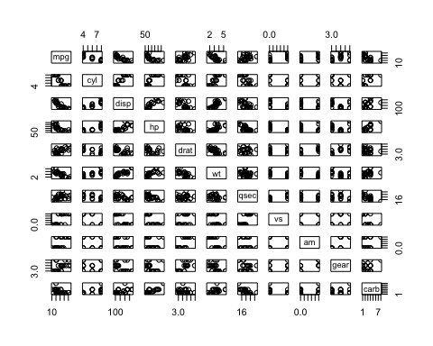

corr_matrix <- cor(train_data[,c(-1,-2)])  
high_cor <- sum(corr_matrix> 0.9 | corr_matrix < 0.9) / sum(corr_matrix)  
high_cor

## [1] 13.36577

hist(train_data$mpg,   
 main="Distribution of MPG in Training", xlab="MPG")

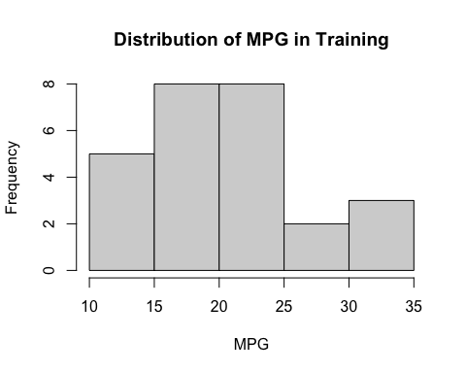

plot(density(train_data$mpg),   
 main="Density Plot of MPG in Training",   
 xlab="MPG",   
 ylab="Density")

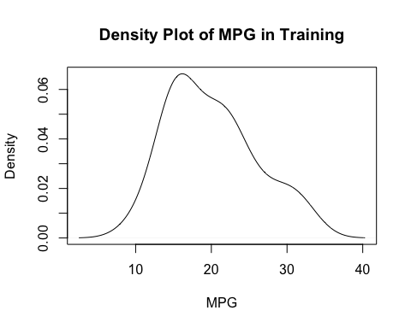

boxplot(train_data$mpg,   
 main="Boxplot of MPG in Training", ylab="MPG")

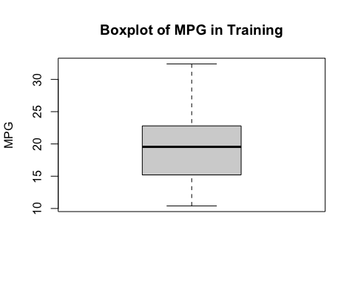 2. Model diagnostics on error (a) constant variance No clear trend on this graph represent the residual could have a constant variance. In addition, ncvTest help prove the contstant variance.

mod1 <- lm(mpg ~ cyl + disp + hp + drat + wt + qsec + vs + am + gear + carb,  
 train_data)  
par(mar = c(5,5,1,2))  
plot(fitted(mod1), residuals(mod1))

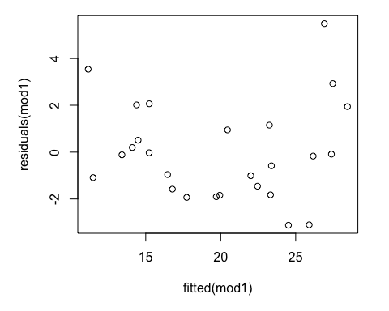

car::ncvTest(mod1)

## Non-constant Variance Score Test   
## Variance formula: ~ fitted.values   
## Chisquare = 2.222176, Df = 1, p = 0.13604

1. normality Due to small p-value, we could not reject null hypothesis of the normality. Thus it is normal.

par(mar = c(5,5,1,2))  
qqnorm(residuals((mod1),   
 ylab = "Residuals",  
 main = 'Residual vs Theoretical quantiles',  
 pch = 18))  
qqline(residuals(mod1))

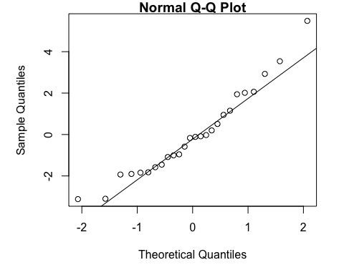

shapiro.test(residuals(mod1))

##   
## Shapiro-Wilk normality test  
##   
## data: residuals(mod1)  
## W = 0.95012, p-value = 0.2334

1. Independence Due to small value 0.03571, we could accept the alternative hyposis that the true autocorrealtion is greater than 0.

dim(train_data)[1]

## [1] 26

y_hat <- mod1$fitted.values  
e_hat <- mod1$residuals  
par(mfrow = c(1, 3), mar = c(4,4,8,2))  
n <- dim(train_data)[1]  
plot(mod1$residuals[1:(n-1)], mod1$residuals[2:n],   
 xlab = " res_i",   
 ylab = "res_i+1",  
 main = "sucessive residual")  
dwtest(mpg ~ cyl + disp + hp + drat + wt + qsec + vs + am + gear + carb, data = train_data)

##   
## Durbin-Watson test  
##   
## data: mpg ~ cyl + disp + hp + drat + wt + qsec + vs + am + gear + carb  
## DW = 1.5555, p-value = 0.03571  
## alternative hypothesis: true autocorrelation is greater than 0

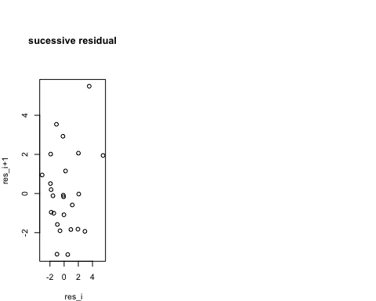 3. Model diagnosis on unusual observation (a) high leverage No high leverage point exist in this data.

hatv <- hatvalues(mod1)  
Car_lev <- data.frame(index = seq(length(hatv)),  
 Leverage = hatv, namesC = train_data$name)  
par(mar = c(4,4,0.5,0.5))  
plot(Leverage ~ index, data = Car_lev, col = "white", pch = NULL)  
text(Leverage ~index, labels = namesC, data = Car_lev , cex = 0.4, font = 2, col = "purple")  
abline(h =2*sum(hatv)/dim(Car_lev)[1], col = "orange", lty = 2)

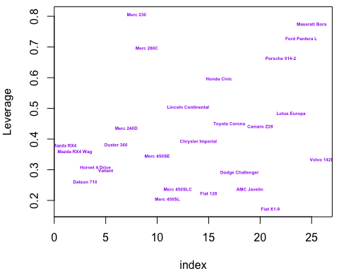

sum(hatv > 2*sum(hatv)/dim(Car_lev)[1])

## [1] 0

high_lev <- train_data|>  
 filter(hatv > 2*sum(hatv)/dim(Car_lev)[1])  
high_lev

## [1] name mpg cyl disp hp drat wt qsec vs am gear carb  
## <0 行> (或0-长度的row.names)

1. outliers In this case, we do not have outlier.

r <- rstandard(mod1)  
outliers <- sum(r > 3 | r< -3)  
outliers

## [1] 0

1. influential observations There are five influential observations exists in our train_data.

X <- model.matrix(mod1)  
H <- X %*% solve(t(X) %*% X) %*% t(X)  
print(H[1:5, 1:5])

## 1 2 3 4 6  
## 1 0.37939459 0.352379043 -0.029983249 -0.02826913 -0.04532256  
## 2 0.35237904 0.357957531 -0.006488445 -0.06933762 -0.03610984  
## 3 -0.02998325 -0.006488445 0.261212766 0.03569016 0.10706049  
## 4 -0.02826913 -0.069337616 0.035690155 0.30826984 0.22559781  
## 6 -0.04532256 -0.036109843 0.107060489 0.22559781 0.29798286

sum_diag <-sum(diag(H)); sum_diag

## [1] 11

p_star <- ncol(X); p_star

## [1] 11

cook <- cooks.distance(mod1)  
Car_cook <- data.frame(index = seq(length(cook)),  
 cookd = abs(cook), namesC = train_data$name)  
par(mar = c(4,4,0.5,0.5))  
plot(cookd ~ index, data = Car_cook, col = "white", pch = NULL)  
text(cookd ~index, labels = namesC, data = Car_cook , cex = 0.4,   
 font = 2, col = "purple")  
abline(h = 4/dim(X)[1], col = "red", lty = 2)

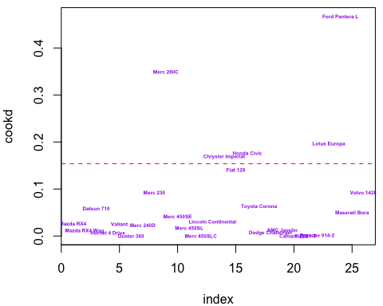

sum(cook >= 4/dim(X)[1])

## [1] 5

1. Transformation Since the confidence interval do not contains lambda = 1, transformation is necessary.

par(mfrow = c(1, 2), mar = c(2, 2, 0.8, 0.5))  
bc <- boxcox(mod1, plotit = TRUE)  
boxcox(mod1, plotit = TRUE, lambda = seq(0.4, 1.3, by = 0.1))

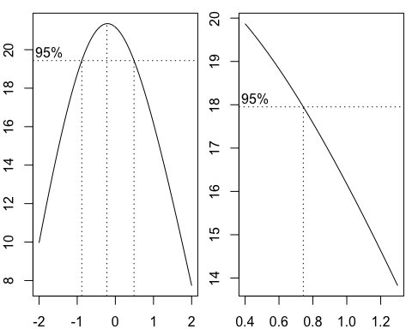

lambda <- bc$x[which.max(bc$y)]; lambda

## [1] -0.2222222

train_data_new <- train_data |>  
 mutate(mpg = (mpg^(lambda)-1)/lambda)  
  
test_data_new <- train_data |>  
 mutate(mpg = (mpg^(lambda)-1)/lambda)  
# change both train and test  
mod2 <- lm(mpg ~ cyl + disp + hp + drat + wt + qsec + vs + am + gear + carb,  
 train_data_new)  
plot(mod2)

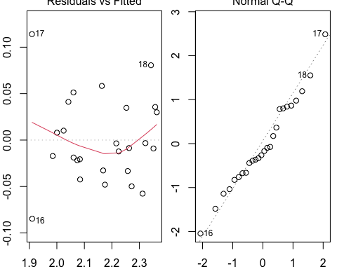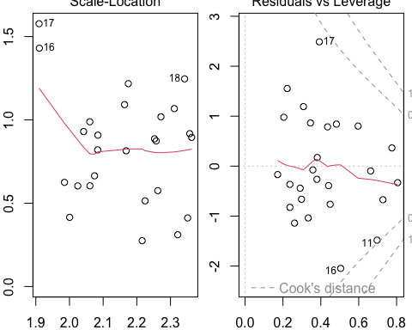

plot(mod1)

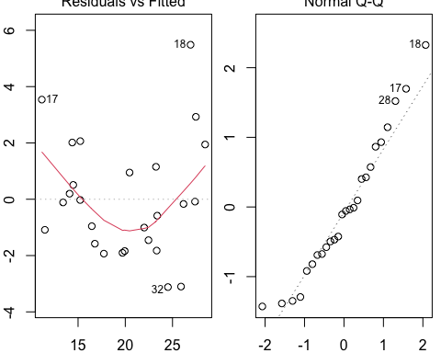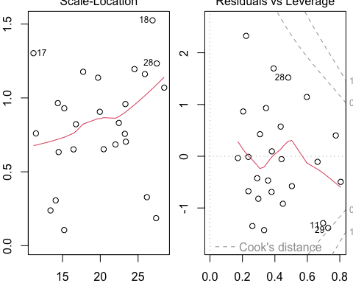 4. model selection After performing the necessary analyses, it was found that the mod3 model (mpg ~ hp + wt + qsec + gear) has the lowest AIC and MSE compared to the other models tested using ridge and lasso regression. Based on these findings, it is suggested that lasso regression favors the inclusion of only the four predictors in mod3.

Furthermore, ridge regression resulted in a higher MSE compared to mod3, indicating that mod3 provides a better fit to the data. However, the difference in MSE between ridge regression and mod3 was not very large. Therefore, if researchers want to include more variables in the model, ridge regression may be a better choice.

step(mod2, direction = "backward")

## Start: AIC=-139.62  
## mpg ~ cyl + disp + hp + drat + wt + qsec + vs + am + gear + carb  
##   
## Df Sum of Sq RSS AIC  
## - drat 1 0.0000127 0.051926 -141.62  
## - vs 1 0.0000235 0.051937 -141.61  
## - cyl 1 0.0002562 0.052170 -141.50  
## - carb 1 0.0003009 0.052215 -141.47  
## - qsec 1 0.0005078 0.052422 -141.37  
## - am 1 0.0007037 0.052617 -141.27  
## - disp 1 0.0008407 0.052754 -141.21  
## - hp 1 0.0021348 0.054049 -140.57  
## - gear 1 0.0024701 0.054384 -140.41  
## - wt 1 0.0036118 0.055526 -139.87  
## <none> 0.051914 -139.62  
##   
## Step: AIC=-141.62  
## mpg ~ cyl + disp + hp + wt + qsec + vs + am + gear + carb  
##   
## Df Sum of Sq RSS AIC  
## - vs 1 0.0000276 0.051954 -143.60  
## - cyl 1 0.0002508 0.052177 -143.49  
## - carb 1 0.0003728 0.052299 -143.43  
## - qsec 1 0.0005087 0.052435 -143.36  
## - am 1 0.0006920 0.052618 -143.27  
## - disp 1 0.0008982 0.052825 -143.17  
## - hp 1 0.0021266 0.054053 -142.57  
## - gear 1 0.0024577 0.054384 -142.41  
## - wt 1 0.0036715 0.055598 -141.84  
## <none> 0.051926 -141.62  
##   
## Step: AIC=-143.6  
## mpg ~ cyl + disp + hp + wt + qsec + am + gear + carb  
##   
## Df Sum of Sq RSS AIC  
## - cyl 1 0.0003680 0.052322 -145.42  
## - carb 1 0.0003935 0.052348 -145.41  
## - am 1 0.0006805 0.052634 -145.26  
## - qsec 1 0.0007615 0.052715 -145.22  
## - disp 1 0.0008903 0.052844 -145.16  
## - hp 1 0.0021799 0.054134 -144.53  
## - gear 1 0.0024402 0.054394 -144.41  
## - wt 1 0.0039513 0.055905 -143.70  
## <none> 0.051954 -143.60  
##   
## Step: AIC=-145.42  
## mpg ~ disp + hp + wt + qsec + am + gear + carb  
##   
## Df Sum of Sq RSS AIC  
## - carb 1 0.0006382 0.052960 -147.10  
## - am 1 0.0009574 0.053279 -146.95  
## - disp 1 0.0013411 0.053663 -146.76  
## - qsec 1 0.0015226 0.053845 -146.67  
## - hp 1 0.0023320 0.054654 -146.29  
## - wt 1 0.0039120 0.056234 -145.54  
## - gear 1 0.0039819 0.056304 -145.51  
## <none> 0.052322 -145.42  
##   
## Step: AIC=-147.1  
## mpg ~ disp + hp + wt + qsec + am + gear  
##   
## Df Sum of Sq RSS AIC  
## - disp 1 0.0007279 0.053688 -148.75  
## - am 1 0.0010949 0.054055 -148.57  
## - qsec 1 0.0032692 0.056229 -147.55  
## - gear 1 0.0033627 0.056323 -147.50  
## <none> 0.052960 -147.10  
## - hp 1 0.0064932 0.059453 -146.10  
## - wt 1 0.0104369 0.063397 -144.43  
##   
## Step: AIC=-148.75  
## mpg ~ hp + wt + qsec + am + gear  
##   
## Df Sum of Sq RSS AIC  
## - am 1 0.0015707 0.055259 -150.00  
## <none> 0.053688 -148.75  
## - gear 1 0.0044069 0.058095 -148.70  
## - qsec 1 0.0066794 0.060368 -147.70  
## - hp 1 0.0094394 0.063128 -146.54  
## - wt 1 0.0308971 0.084585 -138.93  
##   
## Step: AIC=-150  
## mpg ~ hp + wt + qsec + gear  
##   
## Df Sum of Sq RSS AIC  
## <none> 0.055259 -150.00  
## - qsec 1 0.005123 0.060382 -149.69  
## - hp 1 0.012225 0.067484 -146.80  
## - gear 1 0.014106 0.069365 -146.09  
## - wt 1 0.036715 0.091974 -138.75

##   
## Call:  
## lm(formula = mpg ~ hp + wt + qsec + gear, data = train_data_new)  
##   
## Coefficients:  
## (Intercept) hp wt qsec gear   
## 2.1198251 -0.0006875 -0.0788298 0.0128869 0.0442731

mod3 <- lm(mpg ~ hp + wt + qsec + gear, data = train_data_new)  
summary(mod3)

##   
## Call:  
## lm(formula = mpg ~ hp + wt + qsec + gear, data = train_data_new)  
##   
## Residuals:  
## Min 1Q Median 3Q Max   
## -0.081176 -0.030843 -0.009427 0.025218 0.126001   
##   
## Coefficients:  
## Estimate Std. Error t value Pr(>|t|)   
## (Intercept) 2.1198251 0.2045819 10.362 1.04e-09 ***  
## hp -0.0006875 0.0003190 -2.155 0.04288 *   
## wt -0.0788298 0.0211038 -3.735 0.00122 **   
## qsec 0.0128869 0.0092357 1.395 0.17750   
## gear 0.0442731 0.0191219 2.315 0.03080 *   
## ---  
## Signif. codes: 0 '***' 0.001 '**' 0.01 '*' 0.05 '.' 0.1 ' ' 1  
##   
## Residual standard error: 0.0513 on 21 degrees of freedom  
## Multiple R-squared: 0.8997, Adjusted R-squared: 0.8806   
## F-statistic: 47.08 on 4 and 21 DF, p-value: 3.42e-10

X_test <- test_data_new[,c("hp", "wt", "qsec", "gear")]  
y_pred <- predict(mod3, newdata = X_test)  
mse1 <- mean((test_data_new$mpg - y_pred)^2); mse1

## [1] 0.002125338

library(glmnet)

## 载入需要的程辑包：Matrix

##   
## 载入程辑包：'Matrix'

## The following objects are masked from 'package:tidyr':  
##   
## expand, pack, unpack

## Loaded glmnet 4.1-6

x <- scale(data.matrix(train_data_new[, c(-1,-2)]))  
y <- train_data_new$mpg  
  
ridge_model <- cv.glmnet(x, y, alpha = 0)

## Warning: Option grouped=FALSE enforced in cv.glmnet, since < 3 observations per  
## fold

best_lambda <- ridge_model$lambda.min  
best_model <- glmnet(x, y, alpha = 0, lambda = best_lambda)  
  
ridge_coef <- coef(best_model, s = "lambda.min")  
  
plot(ridge_model)

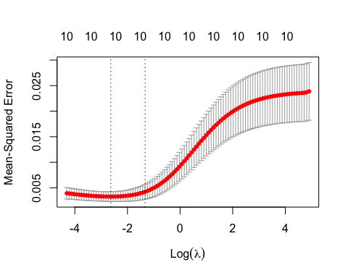

X_test <- scale(data.matrix(test_data_new[, c(-1,-2)]))  
y_pred <- predict(best_model, newx = X_test)  
  
mse2 <- mean((test_data_new$mpg - y_pred)^2); mse2

## [1] 0.002268497

x <- scale(data.matrix(train_data_new[, c(-1,-2)]))  
y <- train_data_new$mpg  
  
lasso_model <- cv.glmnet(x, y, alpha = 1)

## Warning: Option grouped=FALSE enforced in cv.glmnet, since < 3 observations per  
## fold

best_lambda <- lasso_model$lambda.min  
best_model <- glmnet(x, y, alpha = 1, lambda = best_lambda)  
  
lasso_coef <- coef(best_model, s = "lambda.min")  
lasso_coef

## 11 x 1 sparse Matrix of class "dgCMatrix"  
## s1  
## (Intercept) 2.16438687  
## cyl -0.03522733  
## disp -0.04211118  
## hp -0.01315853  
## drat .   
## wt -0.04386359  
## qsec .   
## vs .   
## am .   
## gear .   
## carb .

plot(lasso_model)

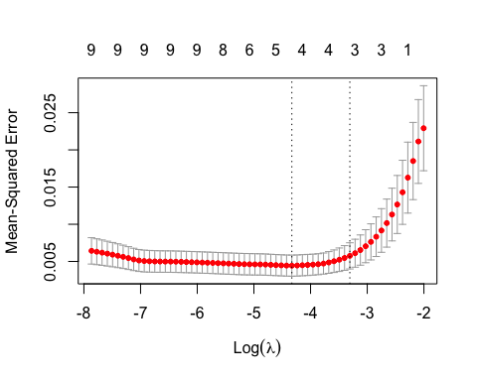

X_test <- scale(data.matrix(test_data_new[, c(-1,-2)]))  
  
y_pred <- predict(best_model, newx = X_test)  
  
mse3 <- mean((test_data_new$mpg - y_pred)^2); mse3

## [1] 0.002406127

mse_combined <- c(mse1, mse2, mse3)  
which.min(mse_combined)

## [1] 1